Exp. No. 4
Design a lexical Analyzer to validate operators to recognize the operators +,-,*,/ using regular arithmetic operators using C

Aim: To design a lexical Analyzer to validate operators to recognize the operators +,-,*,/ using regular arithmetic operators using C.

Program: #include<stdio.h> #include<conio.h> int main()
{
char s[5];
printf("\n Enter any operator:"); gets(s);
switch(s[0])
{
case'>':
if(s[1]=='=')
printf("\n Greater than or equal");
else
printf("\n Greater than");
break; case'<':
if(s[1]=='=')
printf("\n Less than or equal");
else
printf("\nLess than");
break; case'=':
if(s[1]=='=')
printf("\nEqual to");
else
printf("\nAssignment");
break; case'!':
if(s[1]=='=')
printf("\nNot Equal");
else
printf("\nBitNot");
break; case'&':
if(s[1]=='&')
printf("\nLogical AND");
else
printf("\n Bitwise AND");
break; case'|':
if(s[1]=='|')
printf("\nLogical OR");
else
printf("\nBitwise OR");
break; case'+':
printf("\n Addition"); break;
case'-':
printf("\nSubstraction"); break;
case'*':
printf("\nMultiplication"); break;
case'/':
printf("\nDivision"); break;
case'%':
printf("Modulus"); break;
default:
printf("\n Not a operator");
}
}

Output:

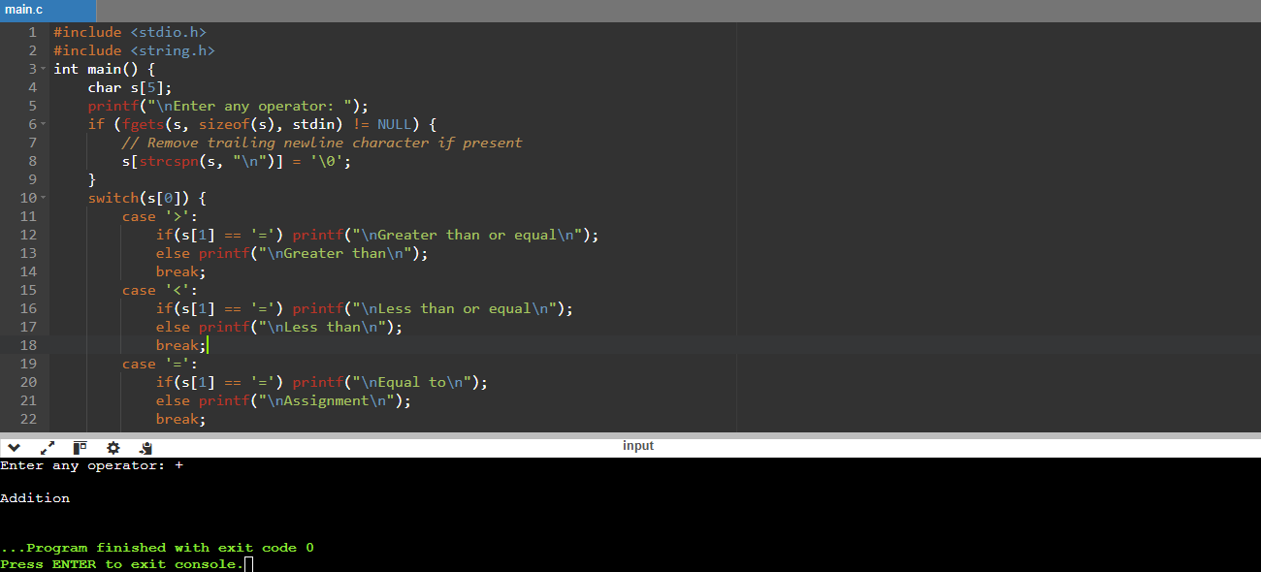

Result: Successfully, designed a lexical Analyzer to validate operators to recognize the operators +,-,*,/ using regular arithmetic operators using C.

